React JS Project Implementation

Title: Caratlane Jewellery Store

By

M.Aishwarya

(maishwarya5@deloitte.com)

Project Introduction

**Project Title**:

Caratlane Jewellery Store

**Software Requirements:**

HTML, CSS, React, Node, JavaScript, JSON Server, Bootstrap

**Project Description:**

The main aim of creating this Caratlane Jewellery shop Web application is to provide user friendly tool for jewellery shops.

This is a very pleasant ui with all required features of adding jewelry to cart and selling it to the users. It has user and admin features where the users are allowed to view the items, add to cart, and increase the number of items in the cart and then checkout whereas the admins can view the items, delete the items, and update details of the items in the cart. It also provides the appropriate description of the products so that the users can pick whatever they like and how much ever they want. It is protected from piracy and stuff and required validations are provided which makes it a safe website.

Home page:

It is the landing page of the application. It has the Home Page, About Page, Login Page, Contact Page, and the Cart component as soon as it loads. Everyone can view the above 5 components. This is run on the 10.70.199.166:1234 port. All the warnings need to be cleared in console to get the alternate host address, and then we can click on it and open the application.

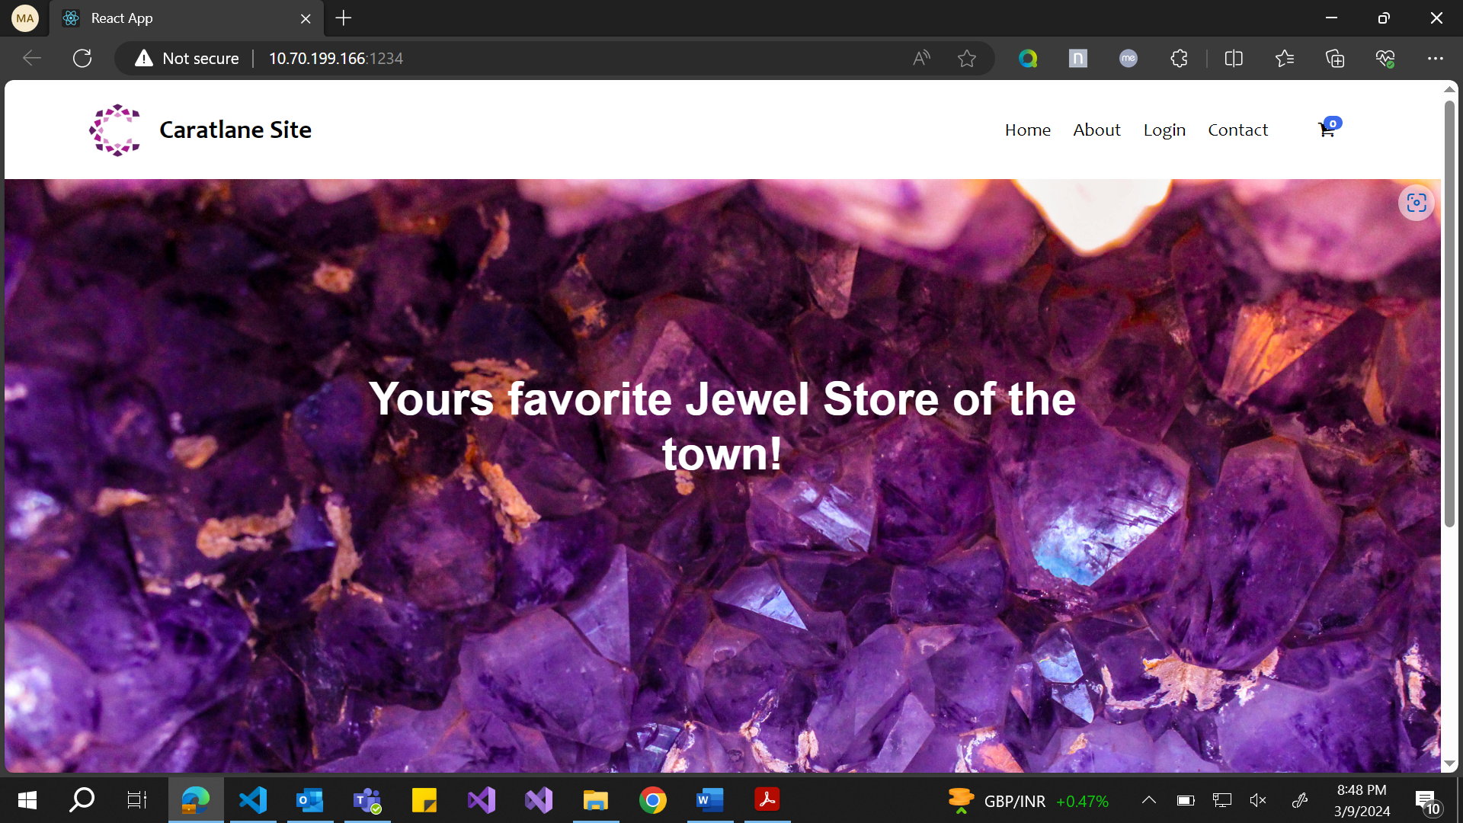

About Page:

The about page contains information about the Caratlane site, who started it and further little details about the store.

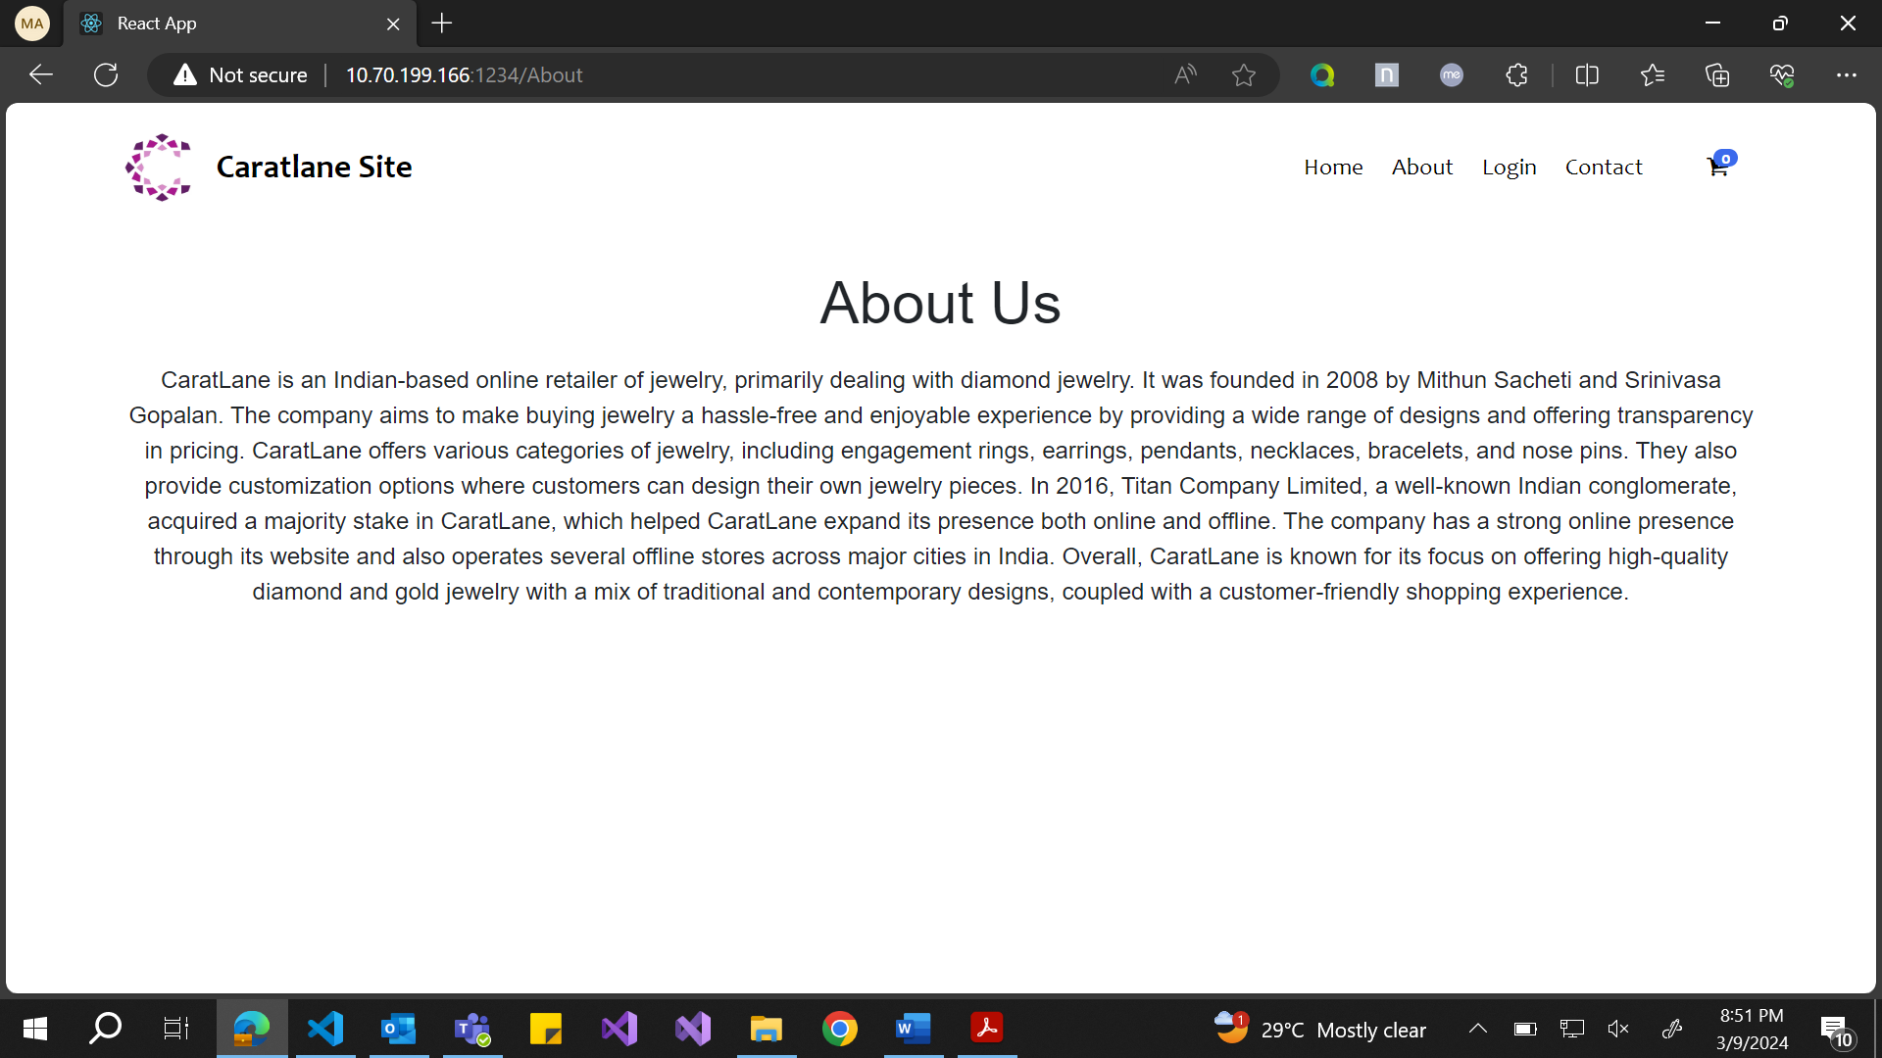

Contact Page:

The contact page contains the ways we can contact us and few details about where the store is present.

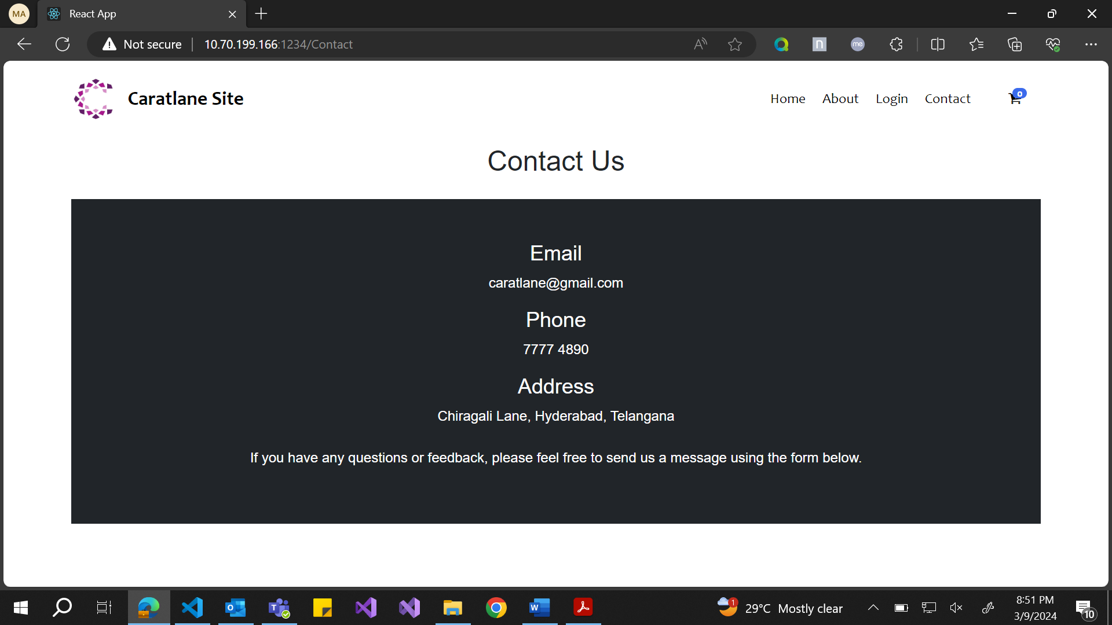

Login Page:

This provides authentication for the users. If the username and password is correct, then the users can login to move further into the site else they would have to stay in the same home page. They wouldn’t have accessed if not authorized. So, 2 stakeholders are here – 1. The user and 2. The Admin. The user would be able to login with user id: **user** and password: **user123** and the admin would be able to login with userid: **admin** and password: **admin123.** The user would be able to view the products and the admin would be able to edit the passwords.

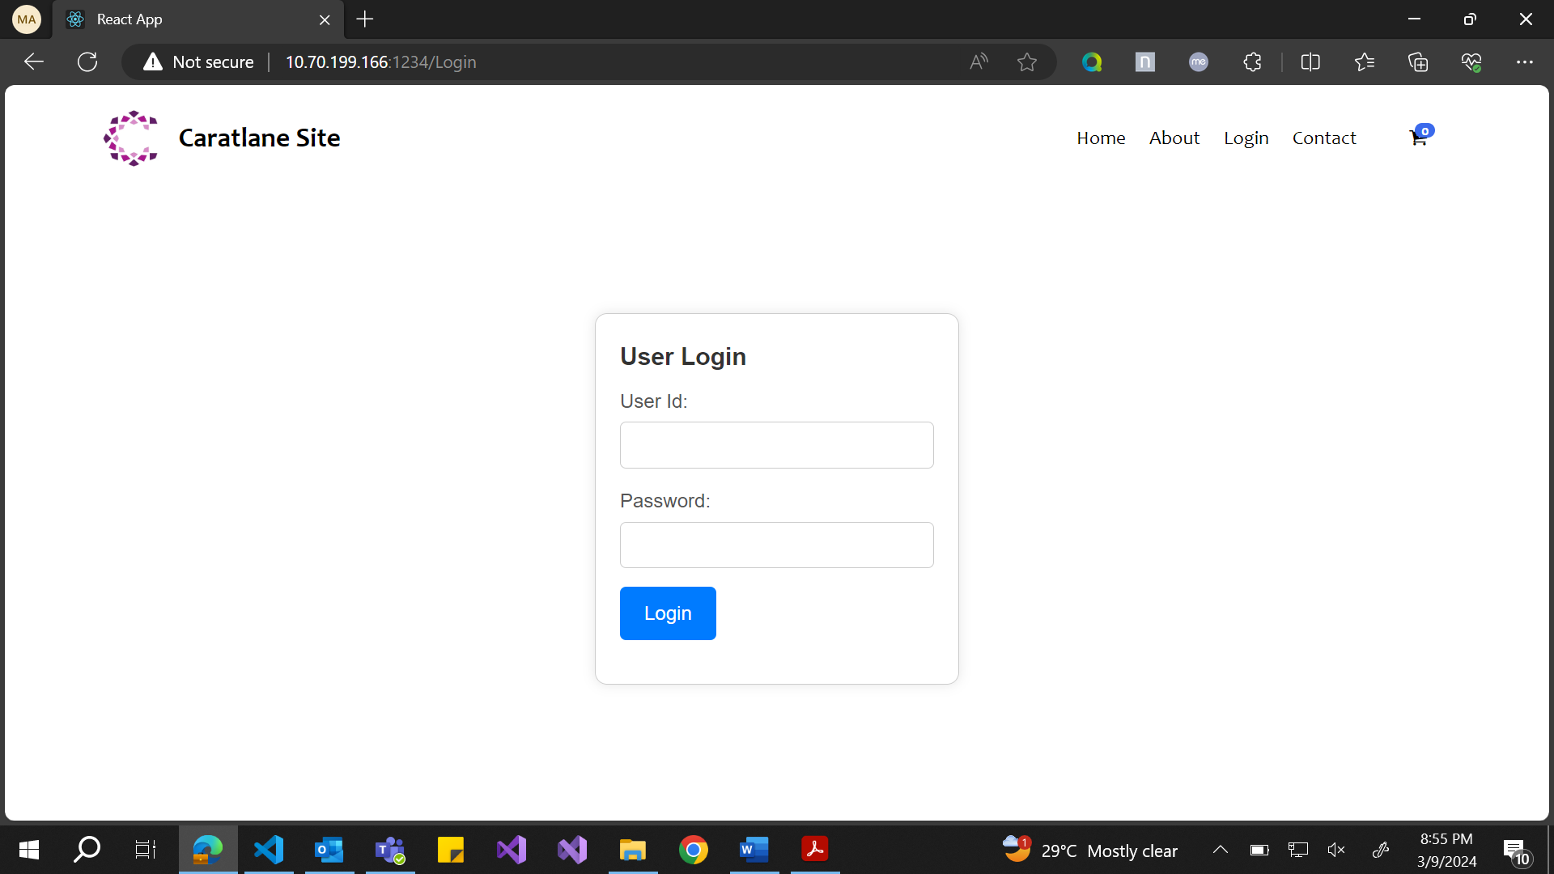

If invalid :

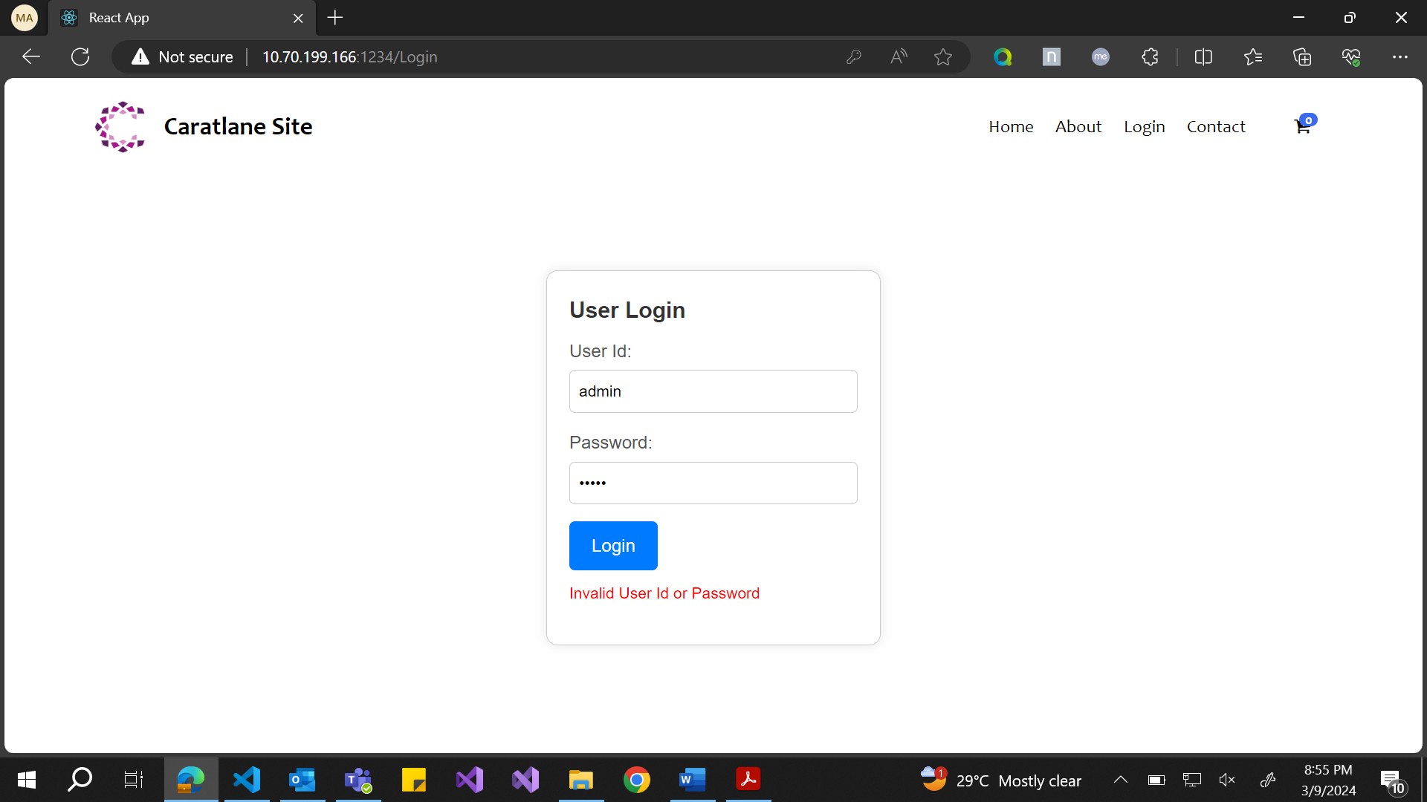

If admin logs in :

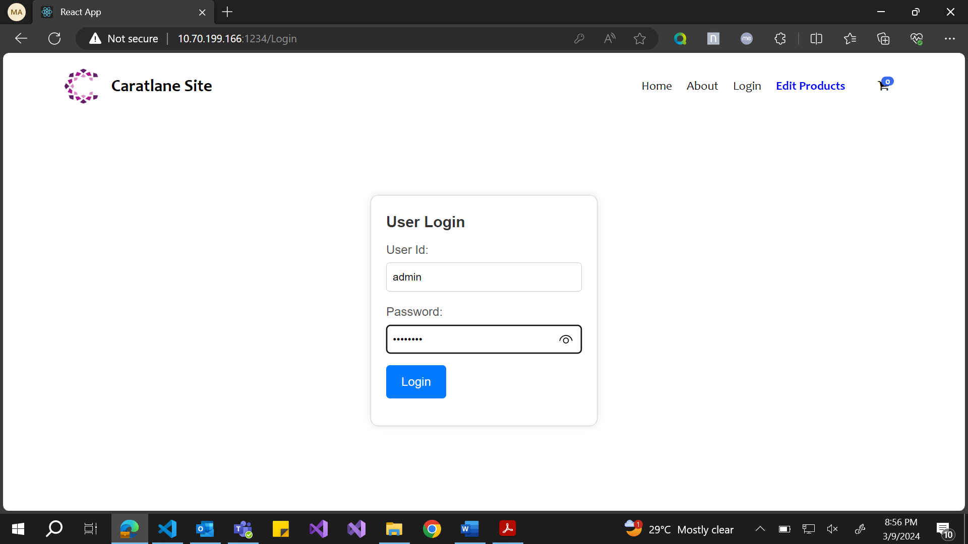

He would be able to see the Edit Products link for editing the products page

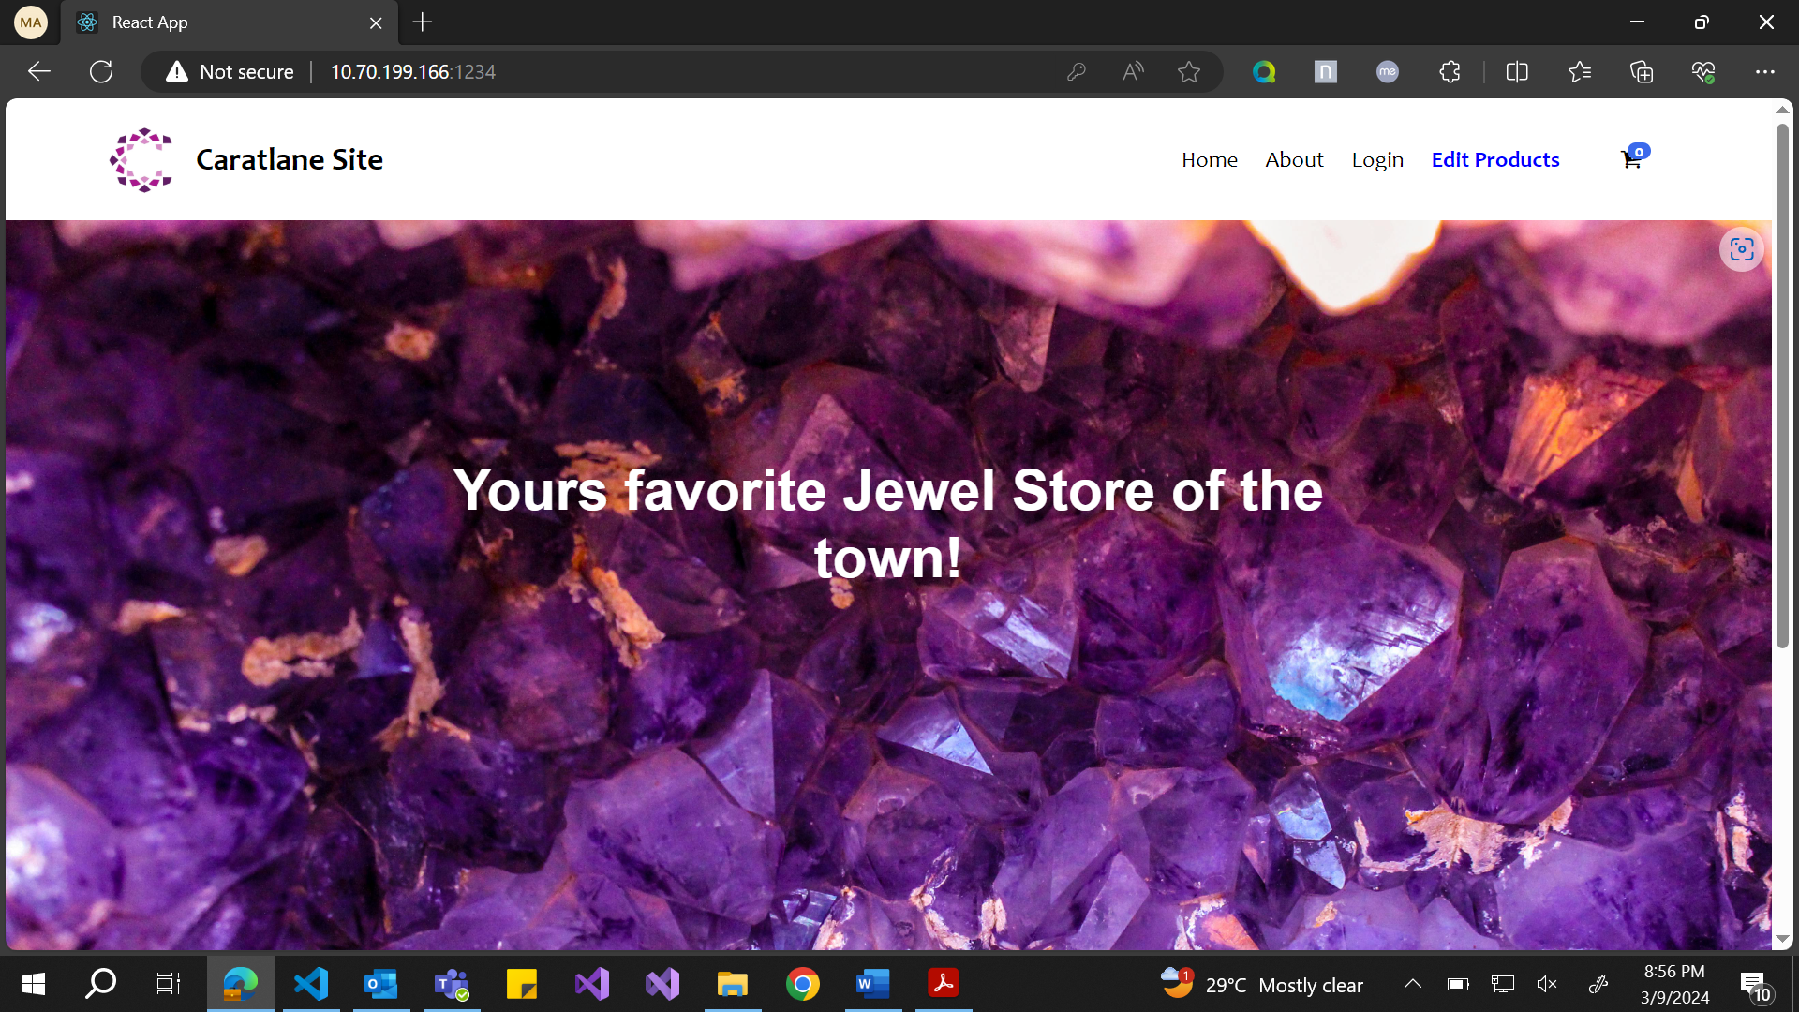

For user login page :

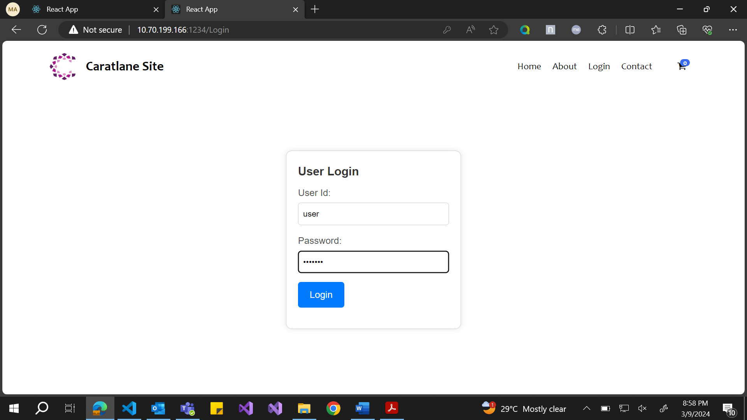

If he logs in, he would be able to see the View Products page :

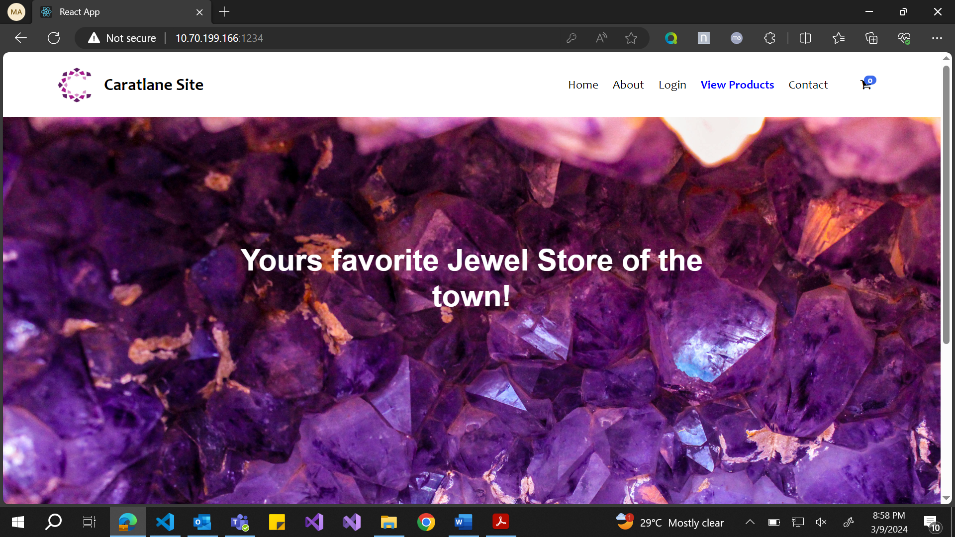

**For the Admin:**

He would be able to see Home page, Contact Page, Login Page, View Products page and Cart.

Edit Products Page:

This is the page where the **Admin** can view the products, select, update the details of the product and delete a product from the database (The json pairs in server).

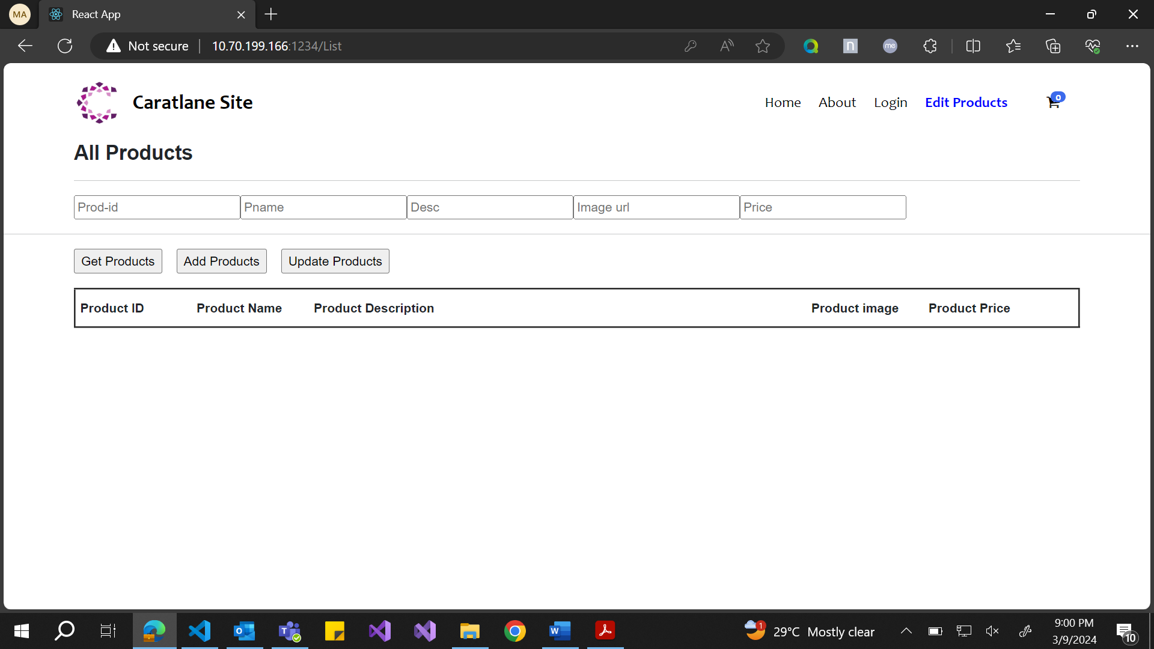

In the above page the details are loading from server when the admin clicks Get Products.

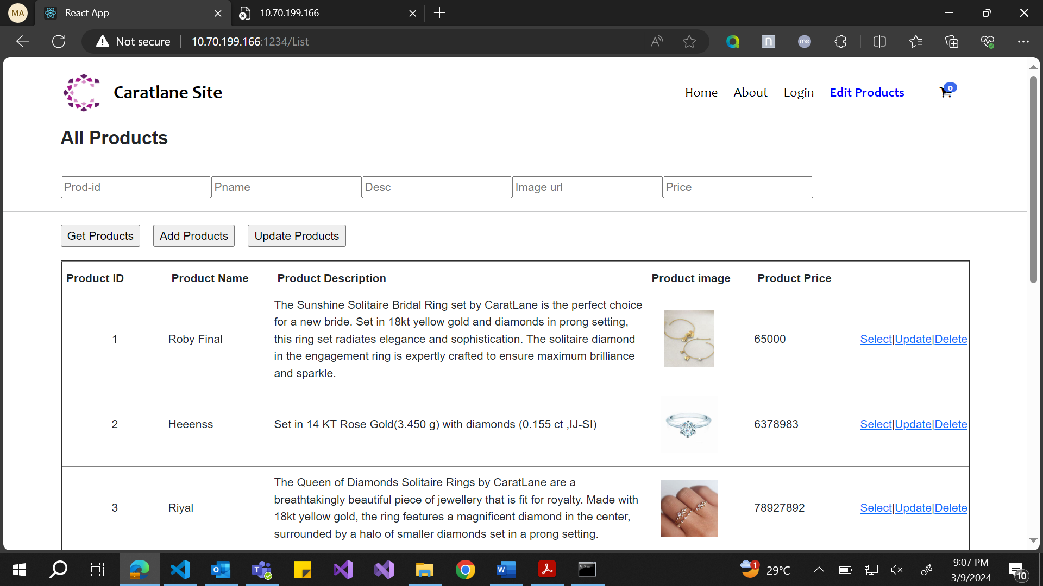

Here, the details are loaded from the server. We have the select update and delete buttons on the right which can help us perform the respective operations on the rows. The Add Products button on the top helps us add products and a pop up comes when we add and then it gets added to the json server json file so technically the data is updated in database and also on the ui, the new item is added.

The select button is used to select the product and then update it accordingly and the update button could be used to update the details.

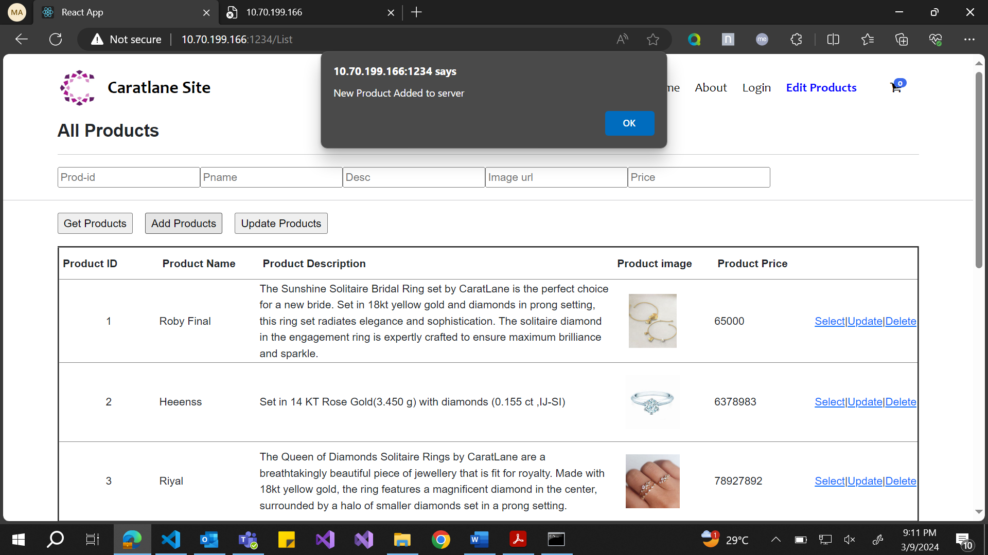

In the above option when a new product is added the required pop up comes that new product is added and gets rendered on to the ui.

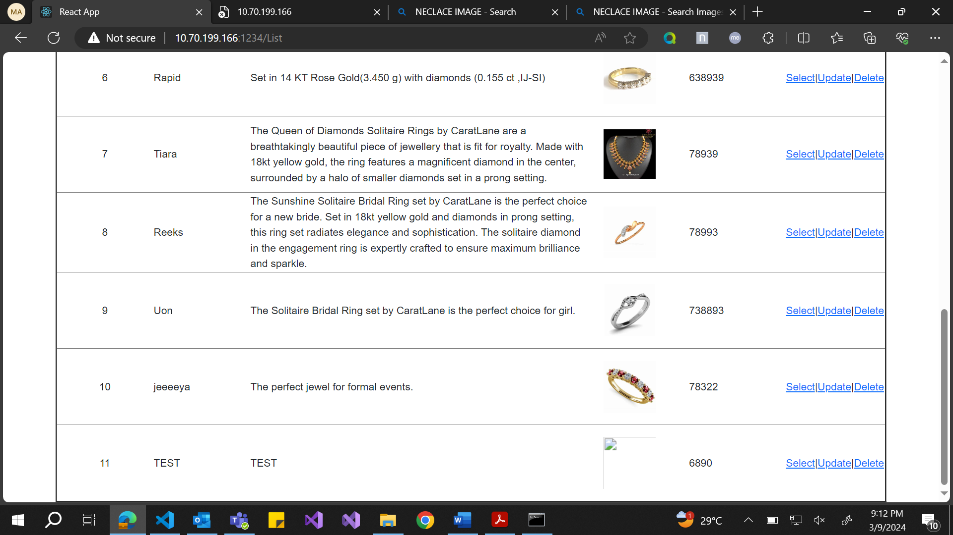

The last row is the new image that has been rendered.

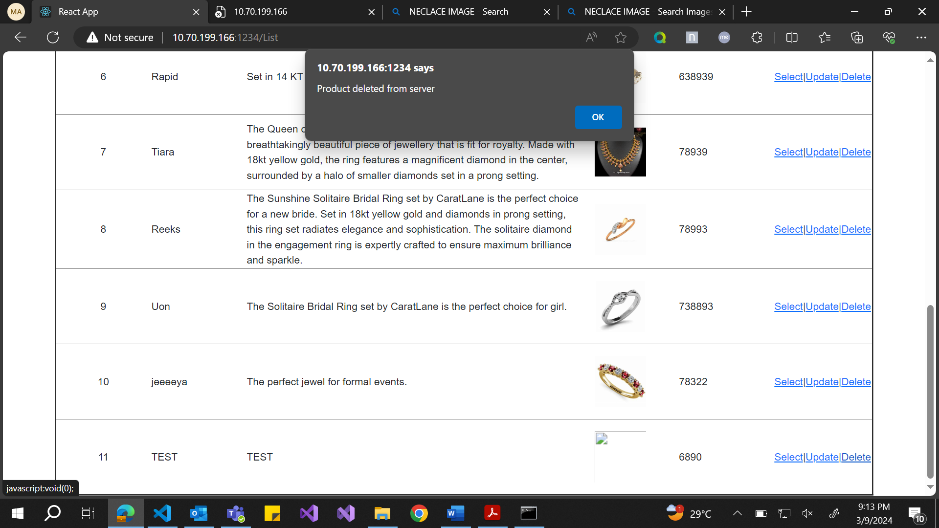

The same image I wanted to delete, so when I click on the delete button then the pop up will give confirmation and then delete.

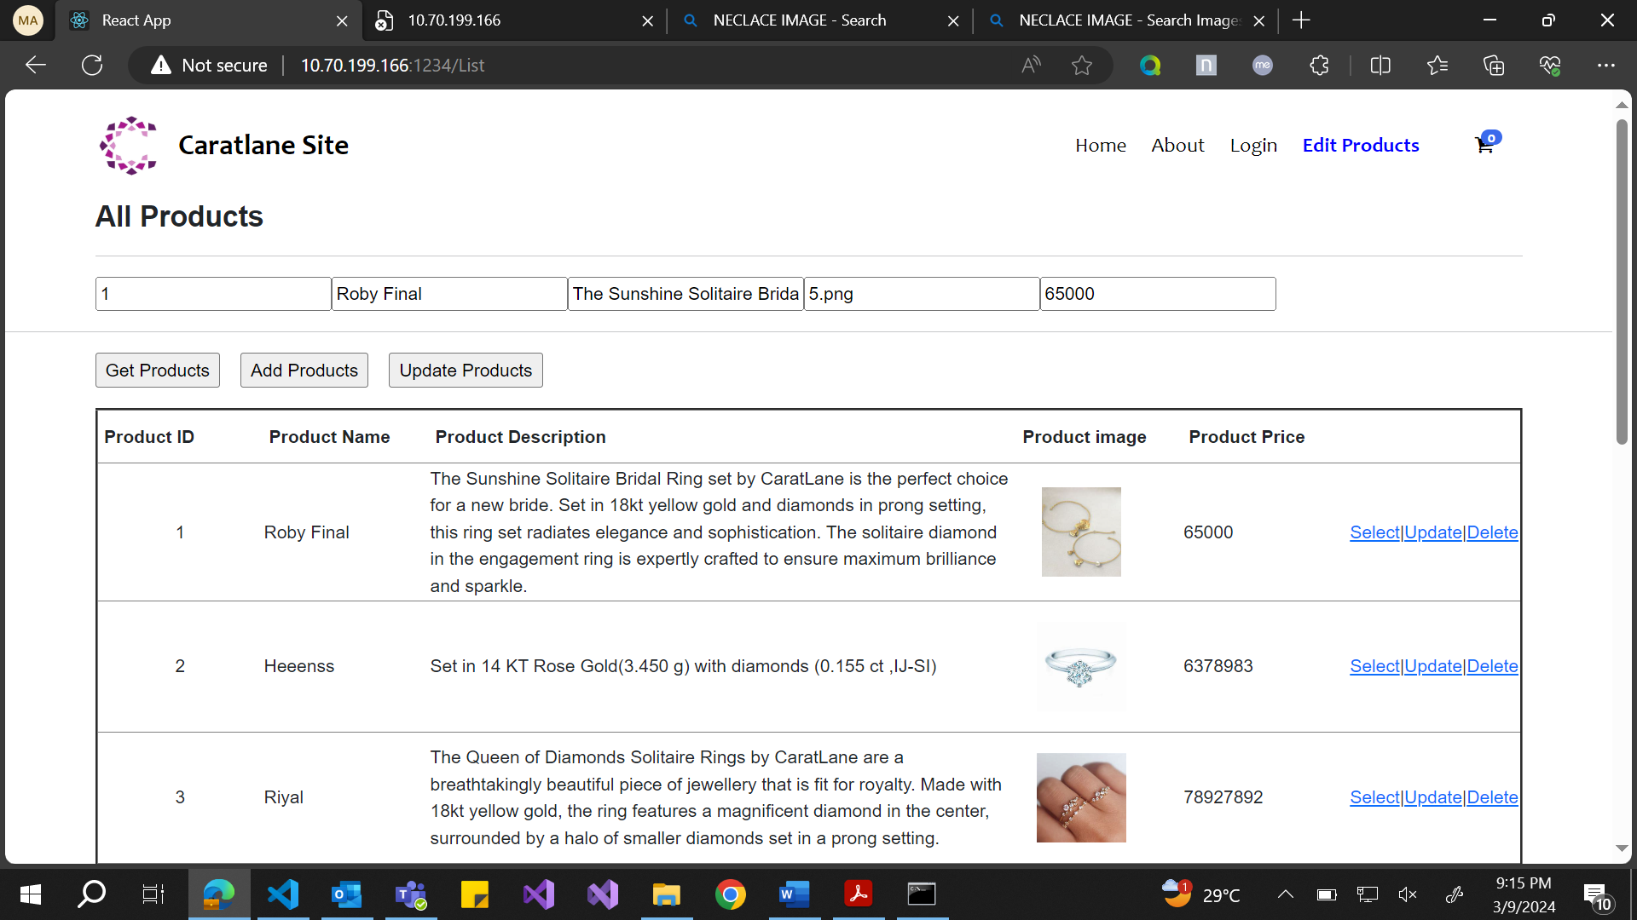

I wanted to update the product, so I selected the required product and then went ahead to change name from Roby Final to Roby.

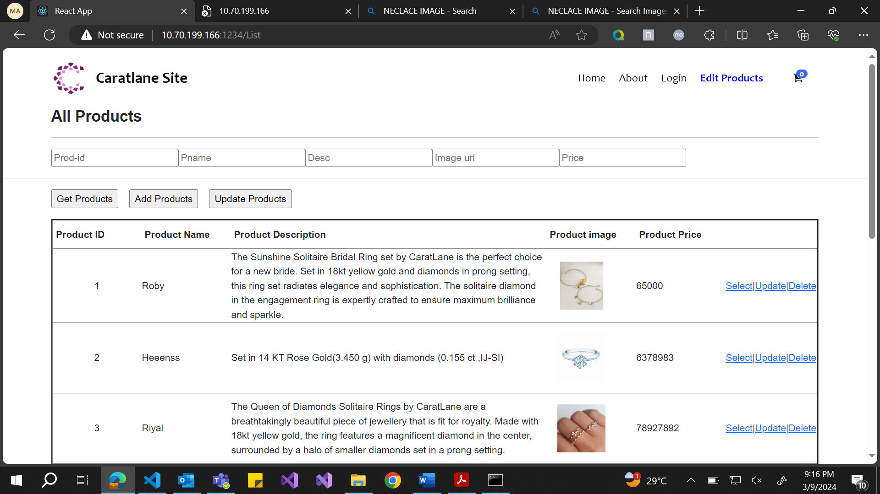

When I clicked on the update button the Roby name is reflected.

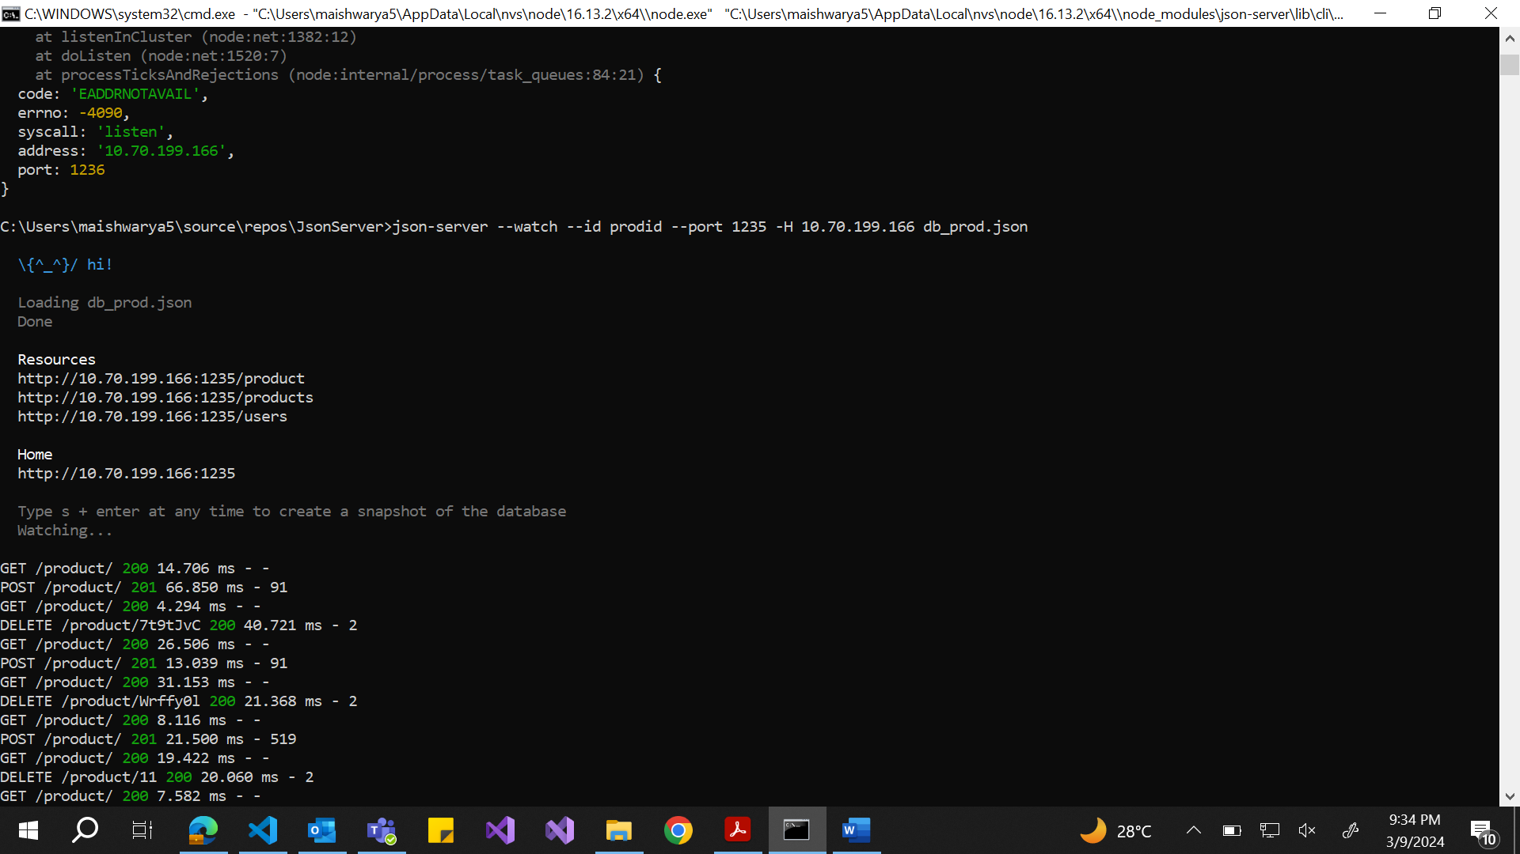

The server is run, and the console tells us what all commands have been performed.

This is the command I executed - >json-server --watch --id prodid --port 1235 -H 10.70.199.166 db_prod.json

The server is run using prodid as the id which acts as primary key and helps to update the products using this key.

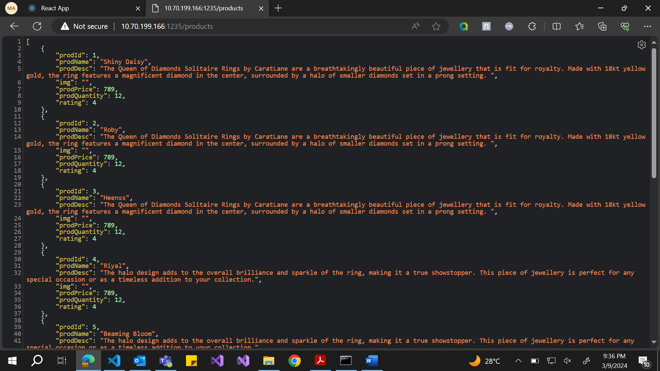

The product details are here and the url is same as react, but port number is different and it is 1235. So, when I type address/products then the details of the products are showed in this.

**User Pages:**

The same data is coming to this page in the form of cards and the user would be able to view the details and would be able to add to cart. This page contains the cards of all the jewels. We can view all the details like picture, name, description, rating, and the button to add to cart.

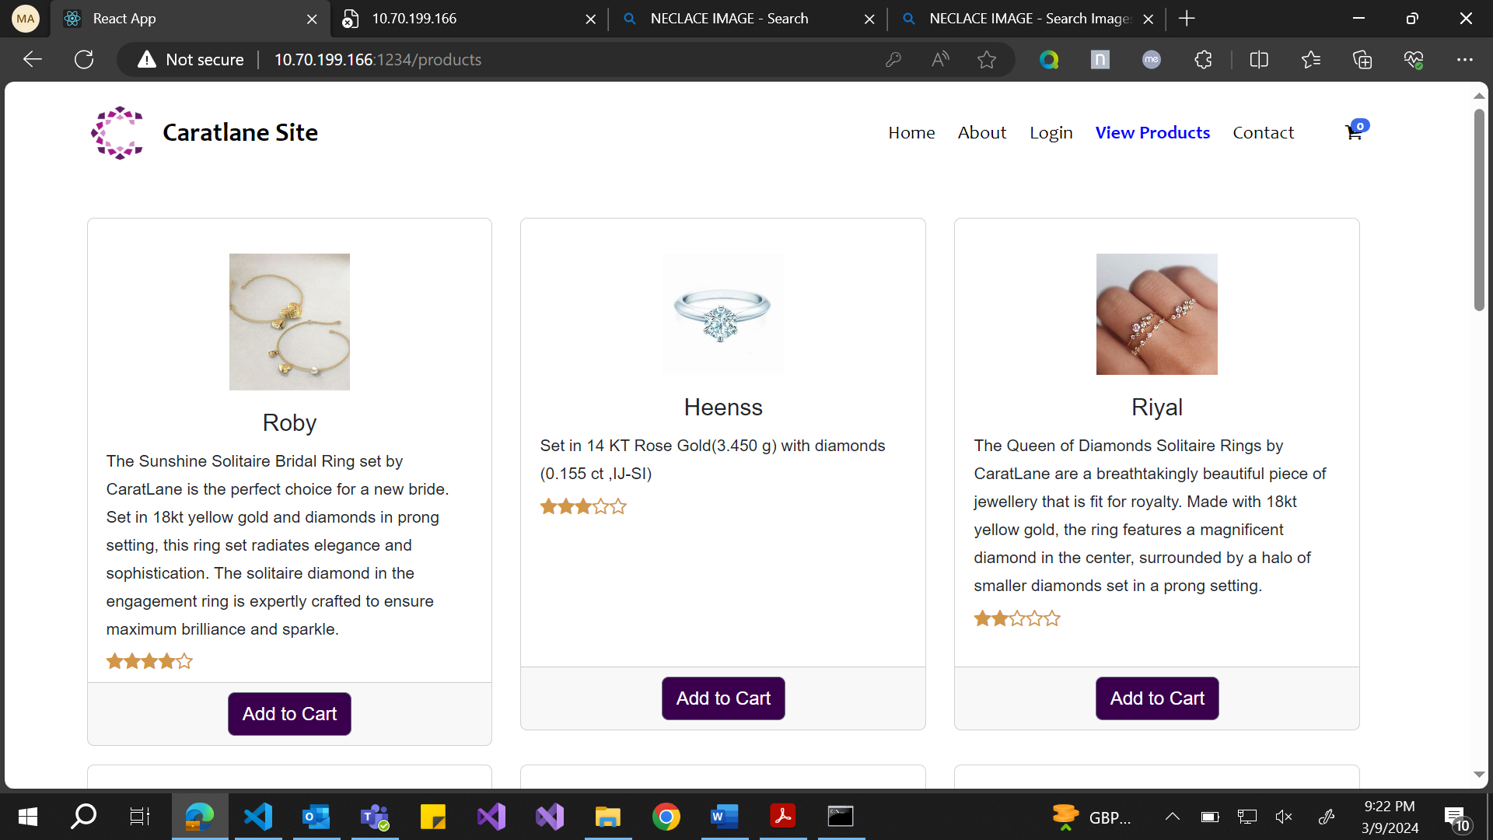

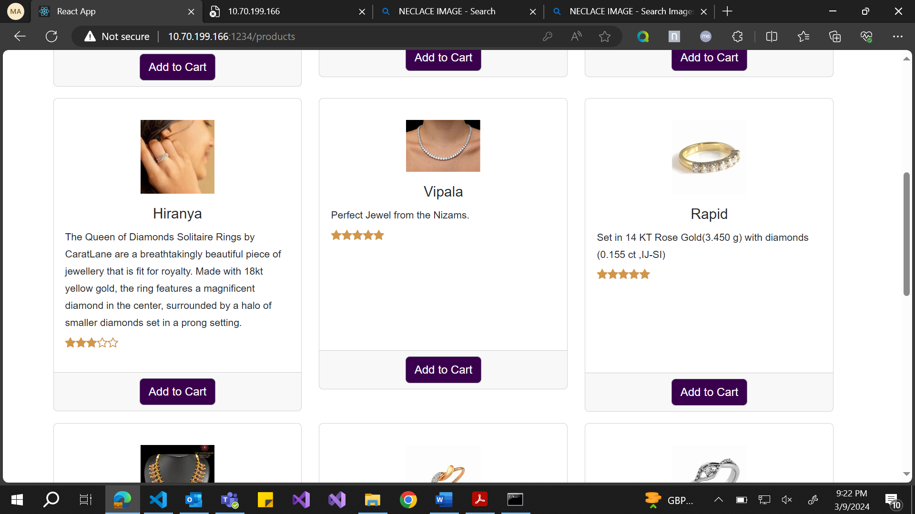

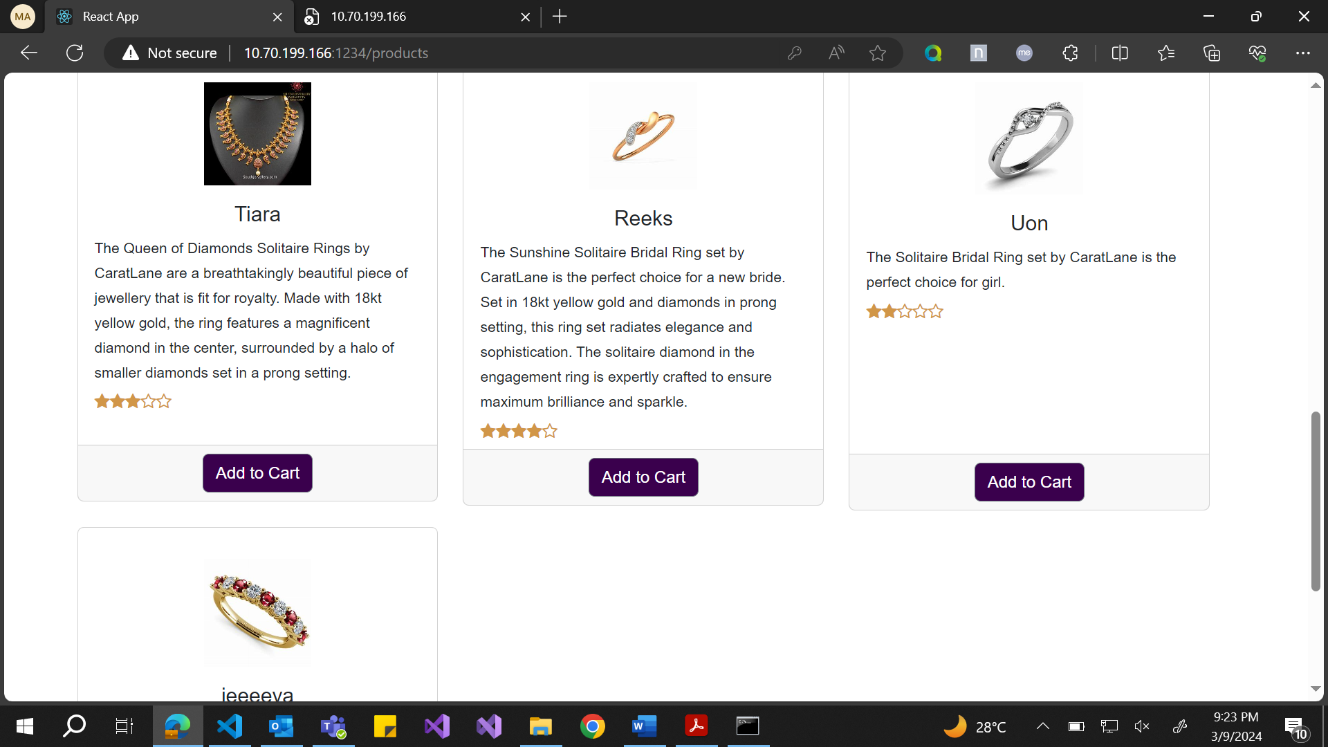

If they click on any **Add to Cart** then that product would be added to the cart icon on the top and the number will turn from 0 to 1

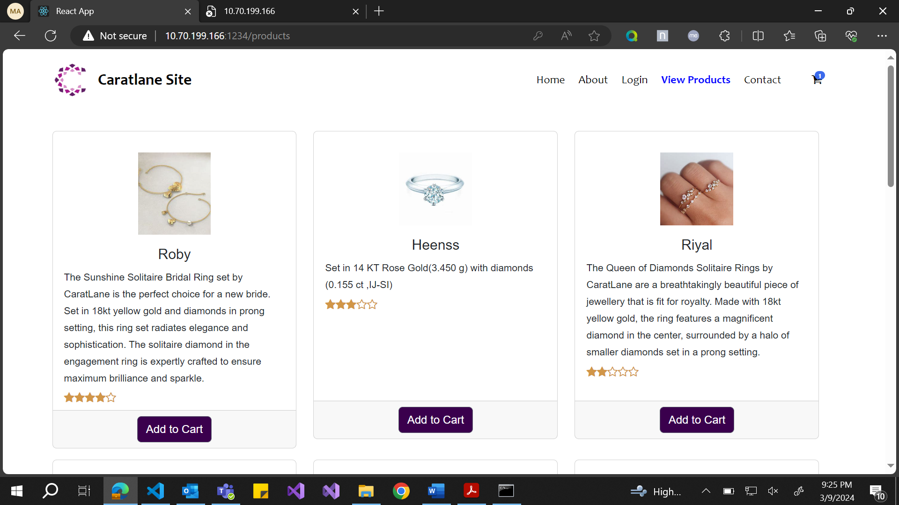

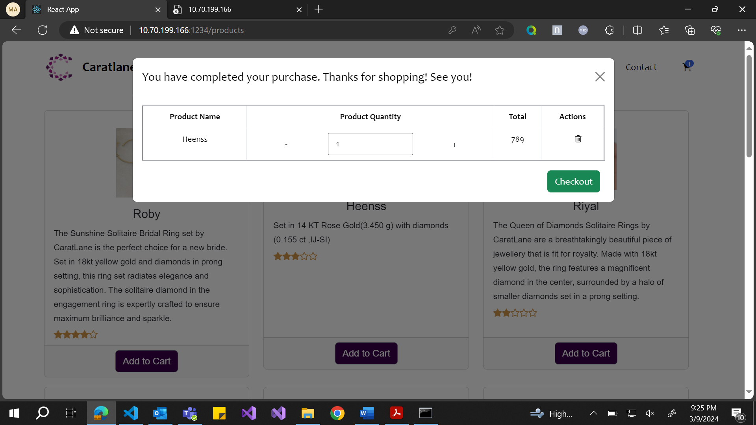

It will be added to the cart as we can see.

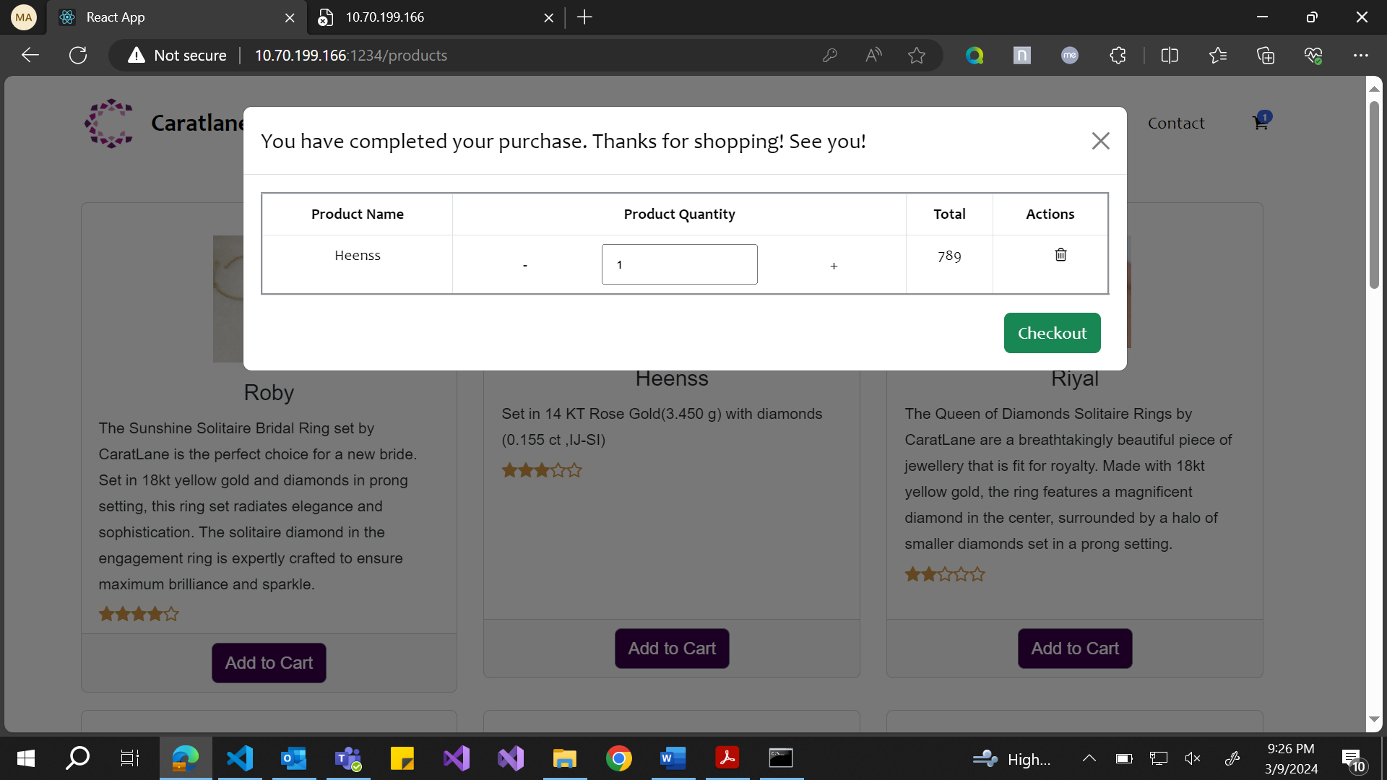

If we click on that icon, then we can see the name of the cart that has been added and then number of items which is 1 as of now and the check out option.

If I click on more Add to cart buttons, then all the products will be added to the cart.

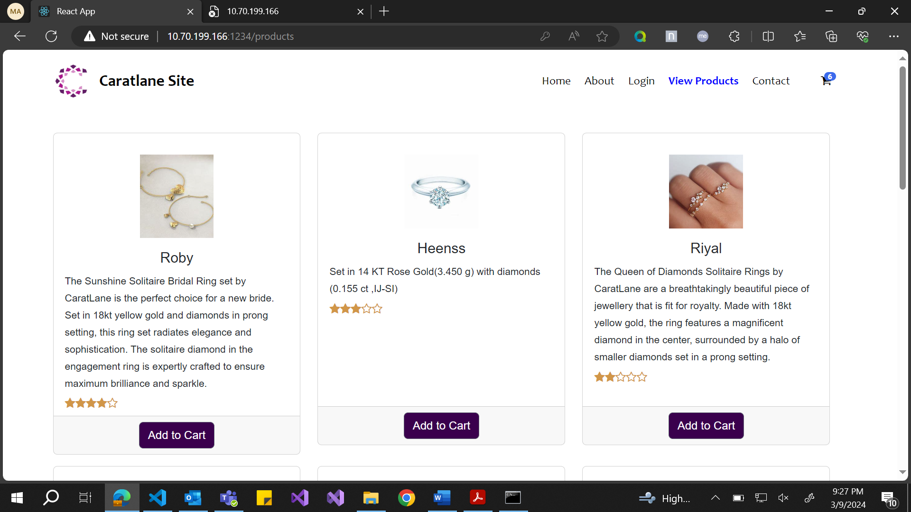

If I click on the same Add to cart button 3 or 4 times say – I clicked on Roby for 6 times to order 6 quantity of same product, then that number is also reflected in the cart.

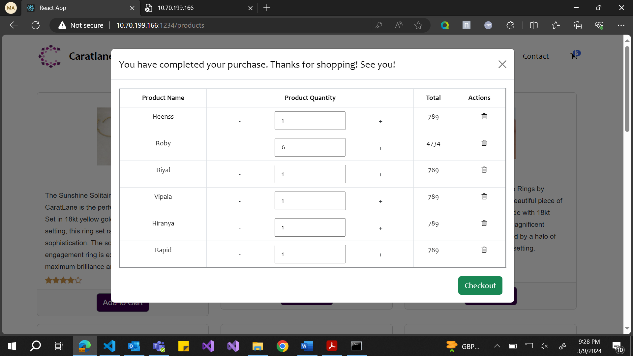

The customer can also delete or add or increase the number using the -,+ and delete icon options present.

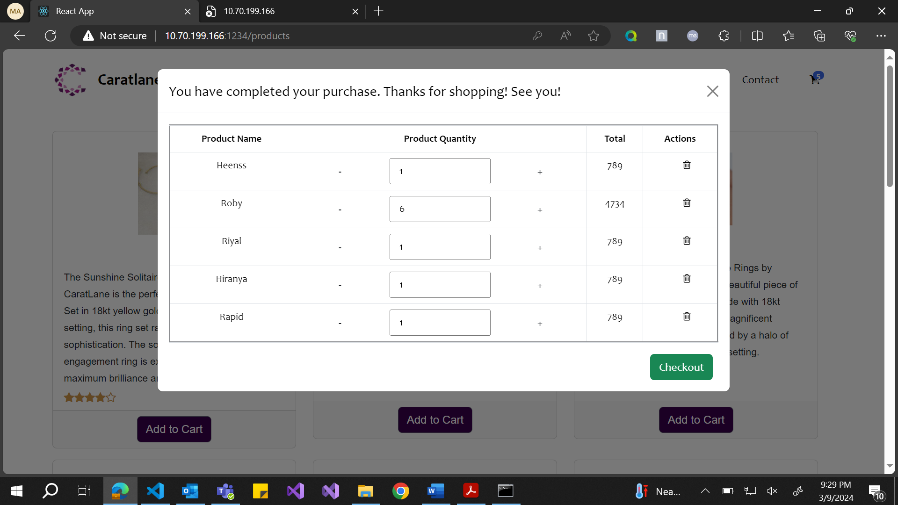I have deleted vipala using the delete option. And it is reflected in the ui as well.

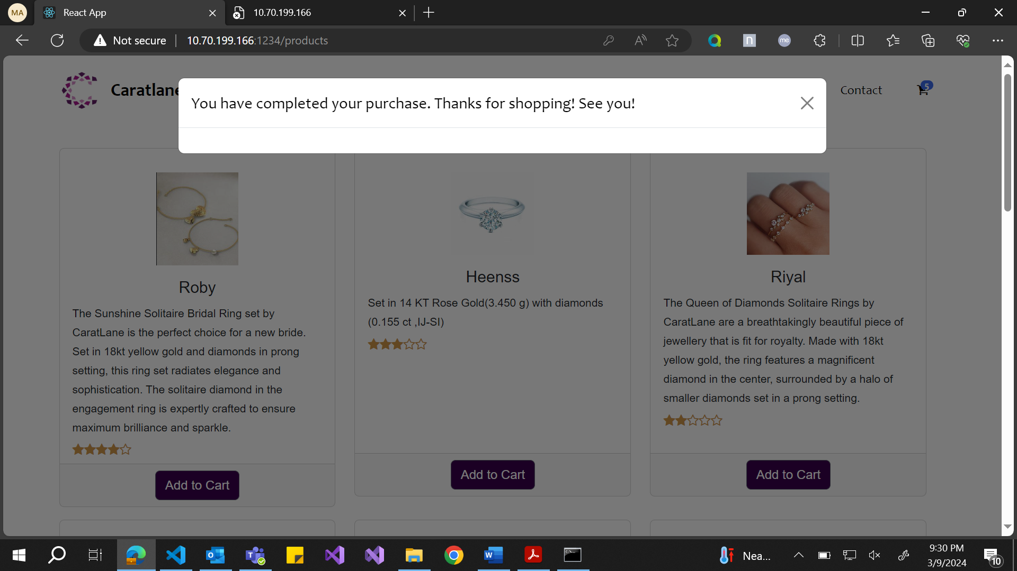

Now since the shopping is over, I have clicked checkout and then the pop up comes up saying Thank you for shopping.

I can click on the close button and continue shopping.

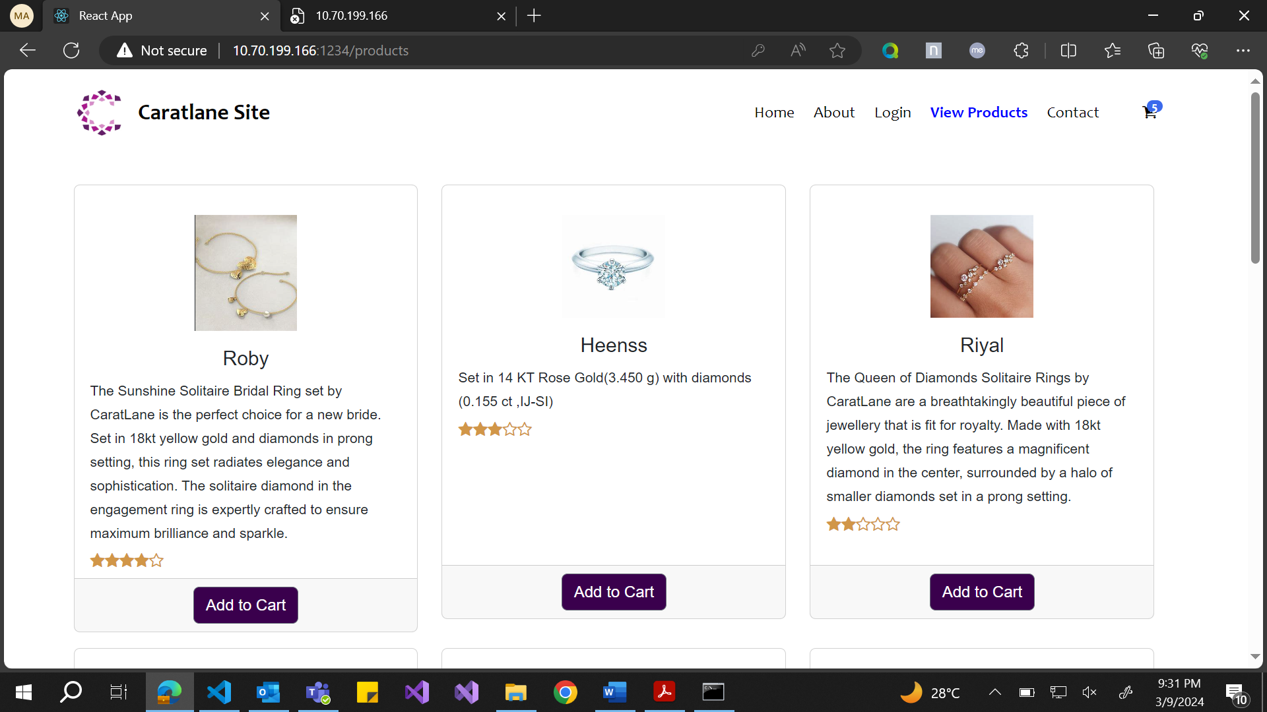

It will reload at same page, and I can continue shopping.

This was briefly about the ui that has been implemented. Hope it really serves the purpose. Hope it does have a unique feel.

This is deployed into the server as well.

